A ESD calendar of Yanagawa elementary school was introduced to the Japan report to which the "ESD world meeting" UNESCO and Japanese Government sponsor was sent for 2014 Aichi Nagoya for the world as a Japanese excellent case.
Development and Popularization of an ESD Calendar that Energizes School Education in Japan and the World
Shinonome Elementary School, Koto Ward/Yanagawa Elementary School, Koto Ward, Tokyo

Summary of Activities:
Shinonome Elementary School in Koto Ward became a UNESCO Associated School (currently, UNESCO School) in 2006 and began school-wide efforts to implement ESD research and practices. Since developing the ESD calendar, a cross-curricular study chart, in 2007, it has been shared both in Japan and abroad, and played a large role in popularizing ESD. It was given the 1st ESD Award.
Influenced by that, from 2010 Yanagawa Elementary School in Koto Ward made improvements to the ESD calendar, added a teaching plan, and succeeded in developing it as a yearly ESD teaching curriculum for each grade that focuses on integrated study time. At the 3rd National Meeting of UNESCO Associated Schools in 2011, the school presented an ESD class together with the ESD goodwill ambassador, Sakana-kun, and the outcomes of implementation were illustrated through the children who attended the class. In addition, each year 500–1,000 CDs containing presentation data for promoting ESD and materials for creating an ESD Calendar in different languages are distributed at various workshops, such as the National Meeting of UNESCO Associated Schools and education groups visiting from overseas. Yanagawa Elementary School was given the 3rd ESD Award.
Both schools are proud of the fact that the initiatives have played a significant role in promoting ESD throughout Japan.

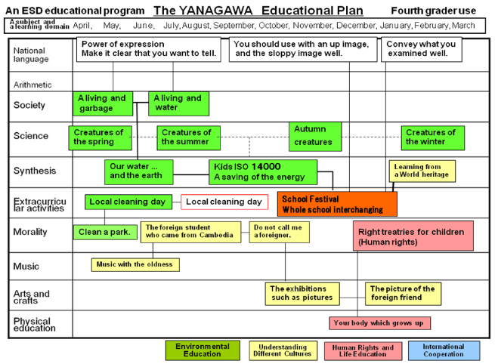
The ESD calendar has been drawn up not only in Japanese, but also in English, Chinese, and Korean, and handed out as data to relevant

individuals.
