On the Frontlines of the International Approach to Education for Sustainable Development (ESD)
The Approaches of UNESCO Associated Schools
Title
Communicating to the World the Value and Achievements of UNESCO Associated Schools in Japan

Summary

The goal of UNESCO Associated Schools is to promote ESD. ESD has the strength to vitalize education, enhance teachers’ outlooks, induce children’s independence, and urge guardians and communities to participate in educational activities. This article investigates ESD’s value and introduces relevant, effective means for the promotion of practice, such as the "ESD calendar" and the "problem-solving learning process format." In parallel, ESD’s characteristics in Japan and information to be dispatched to the UNESCO World Conference on ESD will be provided.

Toshio Tejima: Principal of Yanagawa Elementary School in Koto-ku, Tokyo

1. Development of UNESCO Associated Schools and Significance Thereof

In 2006, there were only 20 UNESCO Associated Schools (called "UNESCO Kyodo Gakko" at that time) in Japan, but by the autumn of 2013 this figure had increased to 647. In December 2013, the large-scale 5th UNESCO School National Congress in Tokyo was held in Tama City. These phenomena indicate that the development of such schools, and the momentum behind them, continues to increase.
It is a significant honor to become a member of the United Nations Educational, Scientific, and Cultural Organization, even if this does not entail significant financial support. Many schools are affiliated with this organization and participate in the activities thereof. This is because UNESCO Associated Schools work to achieve the goal embodied in the slogan "valuable education, the future―ESD."
The values of such schools are crystalized in the following four strengths.
(1) Strength in vitalizing school education as a whole and dramatically improving the educational abilities of schools
(2) Strength in completely transforming the ideas and teaching methods of teachers and tremendously enhancing the quality of such teachers
(3) Strength in enhancing children's awareness and independence in learning, and fostering valuable learning groups
(4) Strength in enabling educational development involving guardians, communities, and associated institutions
The most important achievement that arises from the aforementioned approaches is that children are maturing into "leaders who create a sustainable society." Such an achievement is a necessary condition for developing relevant approaches that can be considered aspects of ESD.

2. The Value of UNESCO Associated Schools

2.1 Strength in vitalizing school education as a whole and dramatically improving the educational abilities of schools
In recent years, school education has been confronted by various requests from general society that go beyond the simple necessities of daily life guidance and academic development. There are requests that the following initiatives be taken:
(1) Initiatives related to ways of life (human rights, the process of life itself, etc.), such as human rights education, measures for bullying and truancy, sex education, education for the prevention of drug abuse, dietary education, measures related to food allergies, consumer education, barrier-free education, career education, and the like
(2) Initiatives related to understanding the culture of children's countries as well as other countries that impart tolerance of heterogeneity and respect for culture, such as those connected with multicultural education, traditional-culture-related education, education in haiku (Japanese seventeen-syllable poems), international education, world-heritage-related education, and the like
(3) Initiatives related to the environment, such as those connected with energy education, efforts by children to reduce CO₂ emissions, conservation of electricity and water, creation of green walls, and the like
(4) Initiatives related to international cooperative systems, such as those connected with UNICEF fundraising, the Red Cross, UNESCO, and the like
In addition, schools are expected to handle requests related to communication skills, such as those connected with information education, foreign language education, and newspaper-related education.
If schools attempt to fulfill all of the requests mentioned above, it would be impossible for them to function. Moreover, the substance of school education could be lost.
In regards to the concept of ESD, all of the demands described above must be accepted from the viewpoint of "creating a sustainable society." Such demands must be roughly categorized as they have been presented above. At the same time, there must be progress in guidance related to learning activities in a variety of areas. The associated viewpoints relate to learning skills, such those for handling information as well as "human rights and the process of life itself," "the environment," "international understanding," and "understanding of international cooperative systems."
According to the theories behind ESD, to start with, there are a variety of requests associated with different areas of learning, and guidance is given in response thereto. Subcategories of learning should be classified into a single category based on the appraisal of relevant viewpoints.
A cross-section of what is learned in a single category that has been divided into subcategories is observed. Such observation has resulted in an awareness of new learning possibilities and connections among subcategories. (Figure 1. ESD Calendar)

An ESD calendar was created based on the aforementioned process. Goals for units, activities, number of hours, community personnel, and the like are expressly entered into this calendar. Thereby, a cross-sectional guidance plan can be formulated. Even if there is a change of teachers during a school year, it is possible to create a school foundation that allows anyone to implement ESD.
The use of the ESD calendar allows education about the environment to be implemented without taking up extra time outside of daily class hours. Human-rights-related education and international education also benefit. Additionally, collection and categorization of relevant information, summarization of such information for newspaper articles, and presentations of such information allow information to be disseminated throughout society with the use of learning skills acquired through the study of each subject. Moreover, children will foster their own self-awareness and a sense of responsibility as members of society.
As described above, the potential for creating a new learning curriculum that goes beyond the limits of conventional subject guidance has been presented.
The 2012 year-end questionnaire survey on UNESCO Associated Schools indicated the following tendencies.
(1) Progress with clarification of school education policies (85%)
(2) Vitalization of educational activities (55%)
(3) Realization of easily accessible schools (35%)
(4) Improvement of educational methods (26%)
Many schools have become UNESCO Associated Schools over the past few years. Given such an environment, it can be observed that many schools are improving their curricula to foster a zest for living and to begin proactively engaging in related activities. Moreover, large problems, such as the promotion of schools that are more easily accessible as well as approaches to problem-solving and exploratory educational methods, have been also observed. Based on the improvements described above, the possibility of ESD that allows overall school education to be vitalized and allows educational power to be improved dramatically has been revealed. At the same time, it has been demonstrated that UNESCO Associated Schools strongly promotes this possibility.

2.2 Strength in completely transforming the ideas and teaching methods of teachers and tremendously enhancing the quality of such teachers

In conventional school education, subject matters were split into segments and taught to children in such format. The degree of student understanding was measured by tests, which were used to determine which students were most successful. On the other hand, through the implantation of ESD concepts, connections among different topics that are imparted in different ways have been discovered. Through cooperation with community personnel and associated institutions, conventional school education has been transformed into education that involves integrated learning approaches. Such approaches make it possible to successively develop, deepen, and transmit information. Given these circumstances, teachers have developed abilities that can be enumerated as follows:
(1) Teachers are able to give educational guidance considering connections among different areas of learning.
(2) Through progress in terms of cooperation with community personnel and associated institutions, learning that involves actual experience and communication on a daily basis becomes possible.
(3) The ESD calendar serves as the basis of the curriculum. Thus, guidance data can be accumulated and shared.
(4) Teachers aim at exploratory and problem-solving guidance. As a result, their classes can become more advanced.
Not everyone is able to conduct exploratory and problem-solving classes. This is because many teachers have not undertaken their classes this way in the past.
However, in order to nurture personnel who will thrive in a demanding world that is expected to drastically change in the future, and who will be able to build a sustainable society, it is essential for such personnel to have superior problem-solving abilities and improved communication skills. Making use of the concept of "motivating children's curiosity to learn," ingenuity is exercised using the following problem-solving course development format:
Strong emphasis is placed on the aforementioned concept. Surprises and unexpected feelings of children are cherished by imparting information that overturns pervious assumptions. In this way, children are encouraged to discover the necessity of learning and researching relevant topics, the sense that they have a mission to communicate what they have learned to many people (such as family members), and a sense of responsibility as an individual who puts learning into practice.
Efforts to improve the method of guidance as described above will result in higher levels of teacher ability. (Figure 2. Problem-Solving Course Development Table)

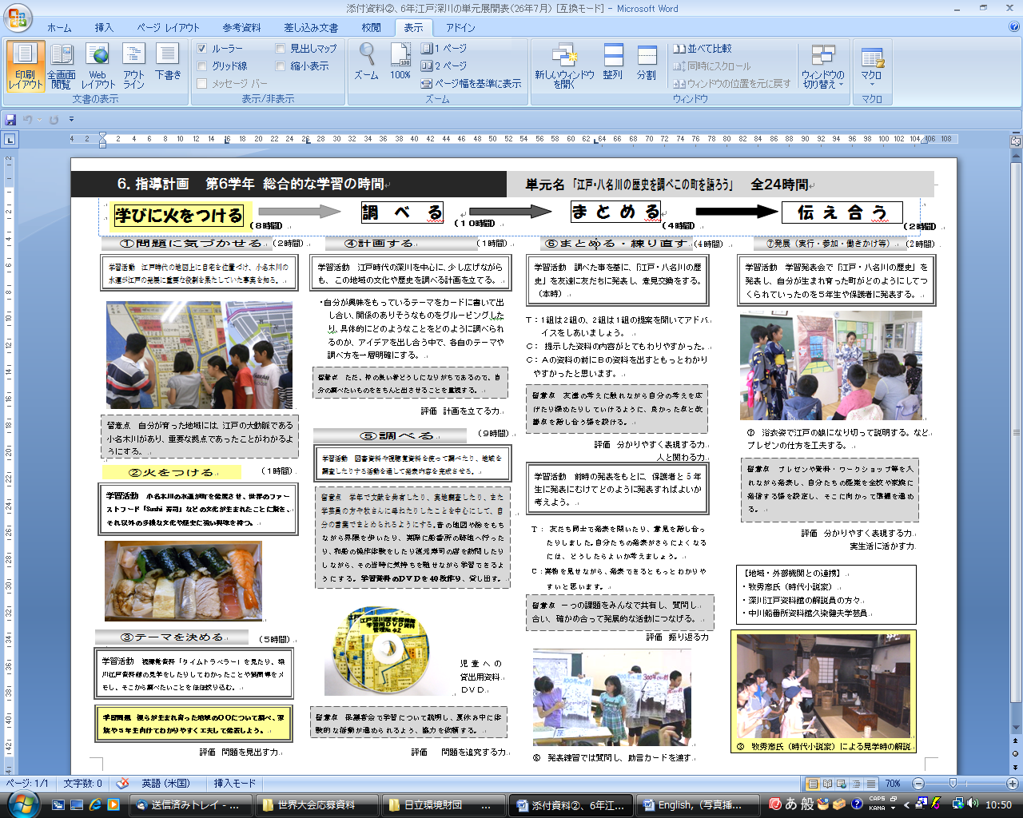
2.3 Strength in enhancing children's awareness and independence in learning, and fostering valuable learning groups

Guidance is provided based on the aforementioned problem-solving course development table. When awareness of a problem crystalizes and topics for learning are determined, various opinions are mutually accepted and problems are defined through the use of the KJ method. In this way, minority opinions can find a voice, and children will be able to adopt different ways of thinking. Children will learn how to solve problems independently, in a manner that allows their own ideas to be adopted.
Moreover, when children think about problems that do not have correct or incorrect answers, those who are not quick learners in every subject can do well in many cases. In this way, children will have more opportunities to enjoy listening to other children's opinions and cooperating with other children.
As a showcase of communication among children, the "ESD festival" is held. It serves as a learning exchange session that allows those of different grades or school years to mingle. In this way, children are able to exchange ideas on methods of transmitting information, give advice to each other, and cooperate with group members at the preliminary stage. They can increase opportunities to have experiences that are not possible in conventional knowledge-communication-style classes.
As described above, as the realization of the concepts behind ESD is pursued, warm relationships are established, and progress is made in creating classes and schools that children feel secure attending. (Crystallization of Problem Consciousness Using Photo Data and Cards)

2.4 Strength in enabling educational development involving guardians, communities, and associated institutions

According to the concepts behind ESD, it is important to have wide-ranging viewpoints and to implement such concepts in a patient manner, thus emphasizing community-based education while focusing on global viewpoints. It is also necessary for children to be able to learn how to live in their own way through contact with those closest to them as well as people around the world.
Unless learning changes children's ways of life, as well as the ways in which family members and communities think, the world will not change. With enthusiasm for these goals, children's growth progresses, as does the vitalization of schools. This enthusiasm will be conveyed to guardians and communities, and relationships of trust will be developed. Moreover, interest in UNESCO Associated Schools and the concept of ESD will be enhanced.
It is significant for schools to be easily accessible to guardians, communities, and the world. The ways of looking at school education will be changed by transmitting relevant information through various opportunities, such as internal demonstration lessons, ESD festivals, and practical exchange sessions of UNESCO Associated Schools, in addition to transmission through school newsletters, parent meetings, webpages, and easily accessible schools.
The words "from observation to participation" express the goal of transforming observers and complainers into partners.
Schools promoting the concept of ESD connect communities and create the future of towns. Such schools play central roles in their communities.

3．ESD: "Hours for Comprehensive Studies" in Japan

The goal of the current curriculum guidelines, which were created based on a basic plan for the promotion of education, is to realize a sustainable society. In particular, the "hours for comprehensive studies" that have been established with the aim of fostering strong lives is one of the major concepts behind ESD in Japan. It is significant for such hours to be established as compulsory hours in the 10-year curriculum running from the third grade of elementary school until the third year of high school. This is a major characteristic of ESD in Japan.
It is expressly indicated in the Description of the Elementary School Curriculum Guidelines that hours for comprehensive studies are intended to foster the ability of children to respond to a remarkably unpredictable society, find their own goals, conduct learning on their own, think about matters for themselves, make subjective judgments, and solve problems in better ways. Therefore, such hours will play an important role in the age of a knowledge-based society. Such a society requires the ability to think, the capacity for judgment, the power of expression, and other similar qualities. Moreover, cross-sectional, comprehensive learning and exploratory activities that go beyond the framework of school subjects will be enhanced by considering experiential learning.
A total of 647 UNESCO Associated Schools (as of December 2013) exist throughout the nation. These schools make it possible to deepen cooperation with workshops and the like related to local life environmental studies, as well those related to hours for comprehensive studies. Such schools are also able to learn from each other, and in the long run, they serve to vitalize education as a whole. More specifically, there is a need for domestic life environmental studies and hours for comprehensive studies to be further bolstered by methods such as the ESD calendar developed by UNESCO Associated Schools based on ESD approaches and a variety of practical case examples.
It is also important to make use of valuable knowledge obtained through ESD research reports by the National Institute for Educational Policy Research, as well as academic conferences and workshops related to environmental education, international education, development education, human-rights education, and the like.

4．Transmitting Relevant Information to the UNESCO World Conference on Education for Sustainable Development
It is important to transmit information on methods and case examples developed by UNESCO Associated Schools at the UNESCO World Conference on Education for Sustainable Development (ESD), which will be held in 2014. It is also important to present educational achievements in areas that Japan excels in when compared to other countries, and of which it is proud. Information on problems related to ESD, including the information described below, must also be presented.
(1) In Japan, over the fifteen years since the revision of the Elementary School Curriculum Guidelines in 1998, the concept of ESD has been extensively implemented nationwide for all school education, with a central focus on "hours for comprehensive studies."
(2) In the process of implementation described in (1), various achievements (See "2. The Value of UNESCO Associated Schools ") have been observed. Examples include improvements in school educational ability, the teaching methods of teachers, children's independence, and communication abilities, as well as participation by guardians and communities.
(3) The aforementioned achievements are also clearly demonstrated by the results of PISA and a survey on national achievement tests.
In any country, no matter how superior the concept of ESD is, ESD will have no meaning if insufficient ESD approaches are implemented. Approaches to be adopted by each country that will allow the world to be changed, as well as the results of such approaches, must be mutually assessed. Information about such approaches and achievements must be brought home as clues on ways to create a sustainable future world.
Moreover, it must be noted that the meetings related exclusively to secondary education that were held during the UNESCO World Conference on Education for Sustainable Development (ESD) in Okayama were the most fruitful. This fact indicates that there is not sufficient power for the ESD approaches in Japan to change the world as a whole. The world must recognize that the current situation is not sustainable, and the parties involved must exchange effective methods to achieve their common goals.
Furthermore, the concepts behind ESD represent important themes in the field of education. In order to create a more advanced sustainable world using the concepts behind ESD, it is essential to engage in approaches with the sense of crisis in a broader field, and to share and transmit information about economics, industry, nations, traffic, international collaboration and cooperation, the environment, and energy, as well as legislation related thereto, and substantial achievements. The leadership of the Japanese government inside and outside Japan is being questioned.
UNESCO Associated Schools continue to provide successful case examples of ESD in Japan. Therefore, such schools must support the Japanese leadership at UNESCO and must carry out their responsibilities for the realization of a sustainable world.

